**Java JDK, JRE and JVM**

**What is JVM?**

JVM (Java Virtual Machine) is an abstract machine that enables your computer to run a Java program.

When you run the Java program, Java compiler first compiles your Java code to bytecode. Then, the JVM translates bytecode into native machine code (set of instructions that a computer's CPU executes directly).

Java is a platform-independent language. It's because when you write Java code, it's ultimately written for JVM but not your physical machine (computer). Since JVM ​executes the Java bytecode which is platform-independent, Java is platform-independent.

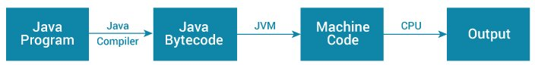Working of Java Program

If you are interested in learning about JVM Architecture, visit [The JVM Architecture Explained](https://dzone.com/articles/jvm-architecture-explained).

**What is JRE?**

JRE (Java Runtime Environment) is a software package that provides Java class libraries, Java Virtual Machine (JVM), and other components that are required to run Java applications.

JRE is the superset of JVM.

Java Runtime Environment

If you need to run Java programs, but not develop them, JRE is what you need. You can download JRE from [Java SE Runtime Environment 8 Downloads](http://www.oracle.com/technetwork/java/javase/downloads/jre8-downloads-2133155.html) page.

**What is JDK?**

JDK (Java Development Kit) is a software development kit required to develop applications in Java. When you download JDK, JRE is also downloaded with it.

In addition to JRE, JDK also contains a number of development tools (compilers, JavaDoc, Java Debugger, etc).

Java Development Kit

If you want to develop Java applications, [download JDK](http://www.oracle.com/technetwork/java/javase/downloads/index-jsp-138363.html).

**Relationship between JVM, JRE, and JDK.**

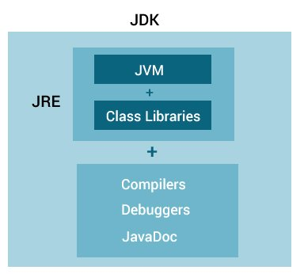Relationship between JVM, JRE, and JDK